CIS 2368 FALL 2025 Final Project

Recipe Manager and cooking helper
For your final project you will be building a full stack web application following a standard 3 tier architecture:
UI – REST API Services – Database

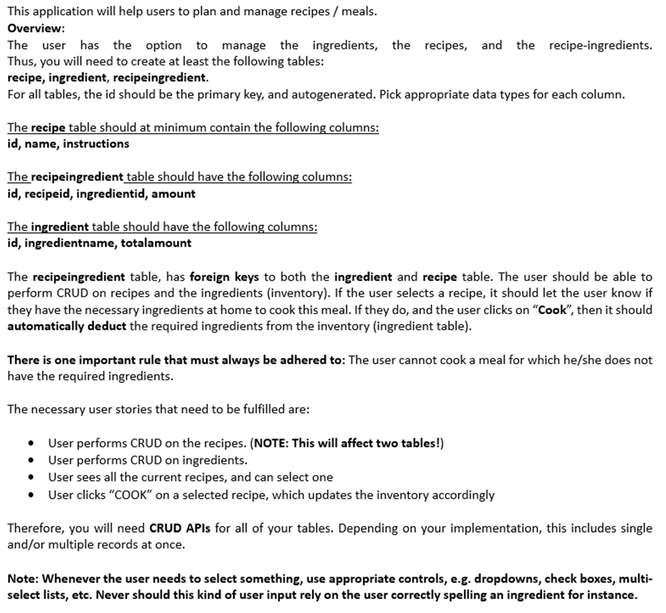

Requirements
This project will be developed in 2 Sprints. The first sprint focuses on the Python backend development, all the logic/functionality, and the deployment of the REST API services with Flask. The second sprint focuses on the UI development in JavaScript using the EJS. Both code submissions will happen into the same repository on GitHub Classroom. There must be a folder 'frontend' and a folder 'backend' in that repo, with the corresponding code bases. Do not forget to comment and document your references.
Each Sprint for the project is due at midnight of the listed due date on the schedule.
No late submission will be accepted.
Part of the submission for Sprint 2 will be a 3-5-minute long presentation video, giving an overview over the functionality of your application features, and explaining the technology, frameworks, etc. that you have used. This video must be made available through a link (for instance, recorded with MS Teams and provided is the link to MS Stream). Do NOT submit video files on CANVAS or in your repo! Commit the link in a text file in your repo!

Details for Sprint 1 - Deadline October 25th, 2025
For Sprint 1 you will have to design and implement all the REST API services you will need so that your app can interact with your database. (ALL CRUD operations for all the tables.)
These REST Services need to be implemented using the Python Flask Framework. You will be testing your backend code with Postman, without the need to have the UI pages implemented.
On CANVAS, submit the link to your GitHub repo. If you work as a team of two, one person needs to submit the GitHub classroom link on CANVAS, and the other person MUST submit a note stating the name, student ID, and section of their partner.
You are allowed to make modifications and changes to your Sprint 1 code even after the submission deadline, but only the last commit before the deadline will be considered for grading.

Details for Sprint 2 - Deadline December 6rd 2025
You can choose to let the user manage all necessary CRUD operations on one page (SPA) or on individual pages (multi page application). You can use any of the templates introduced in class if you like.

NOTE: Under no circumstances should the user ever see the ids used as primary keys on any of the pages! (You can, however, introduce secondary Ids of your choice of you want, for instance SKUs for ingredients).

Other Requirements
- Make sure the username and password for the database you setup are credentials you’re willing to share. Do not use personal passwords for this project, which you might be using anywhere else.
- Make sure your project compiles and runs. If the project doesn’t run, you will forfeit points.
- Submit early and often! Only code that has been submitted to your repo can be graded.
Unexpected circumstances can occur (power outages, etc) – make sure you have commits to fall back to if need be.

- Use GitHub Classroom to setup the remote repo for this assignment Use the provided link to create your private GitHub repo:
https://classroom.github.com/a/cCQND177

Please push your commits on a regular basis.
What to Turn in:
Commit your source code (properly commented) to your folders in your private repository in the GitHub classroom. Do not zip the files together. Your GitHub repository should show multiple meaningful commits illustrating how you worked through the project.
There will be 2 separate assignments listed in CANVAS - one for each sprint, so that 2 separate grades can be assigned. Each assignment/sprint will be worth 50 points max. Together, they are worth 100 points max for the final project (not counting the extra credit).
For both sprints, on CANVAS simply submit the same link to your GitHub repository containing your project. When working in a team, submit a project document 24h before due date for BOTH sprints, outlining the work distribution among the team members. It should be part of your repository (no separate document submission on CANVAS). For Sprint 2 just update the project document. Also remember, both team members must make a CANVAS submission as stated above, to be assigned a grade. This applies to both Sprint 1 and Sprint 2!
Additionally, you will need to submit the link to your video presentation. The video MUST be accessible for everyone to stream/view (verify the link before submitting). Do NOT upload or commit a video file
(.mp4, .avi, etc.) The presentation video does not have to be narrated/showcased by both team members. However, both team members must be aware of each other’s code. The video should first showcase the functionality of the project (without any technical details, 1-2 minutes), followed by a short technical review of the project, detailing the concepts, frameworks, techniques, etc used for this project (2-3 minutes). The total length of the video should be around 3-5 minutes.
Do NOT submit anything via email!
Both team members will receive the same grade for the project.
Extra Credit
You can earn extra credit if you are able to deploy the Python Flask API and/or the web front-end to the cloud. Do not attempt this until you have finished the other parts of the project. There are many options for cloud deployment (AWS, MS Azure) and you are free to choose one that supports the technologies of this project (Python Flask backend + NodeJS/EJS based front-end). Submit your public URL of the deployed project in a text file as part of your repository.

Basic Grading rubric for the project
Item | Points in Sprint 1 | Points in Sprint 2
Remote DB Tables setup | 10 | -
Code for API | 35 | -
Correct submission (GitHub commits, CANVAS link) | 5 | -
Code for UI | - | 20
Code for API communication (both ways) | - | 25
Correct submission (GitHub, CANVAS, including video) | - | 5
Total | 50 | 50
Extra credit for cloud deployment | 15 points | 15 points

